# Spring batch

Features

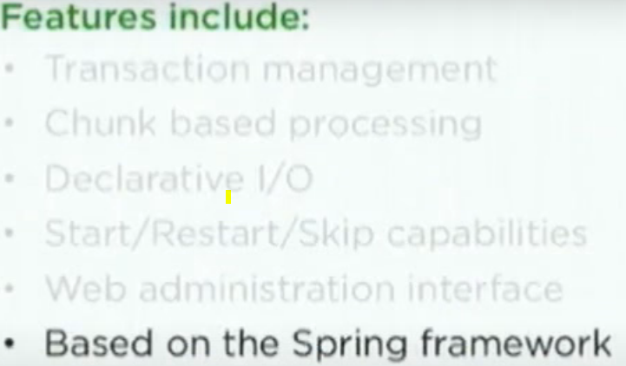

## How to tune the performance

1.Parallel steps- each step must be completely runnable

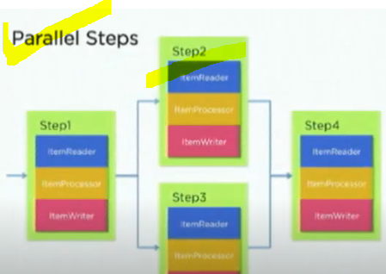

2.Remote partitioning, Remote Chunking

